REPORT FOR TASK 2, VARIANT # 8

1. First subtask:

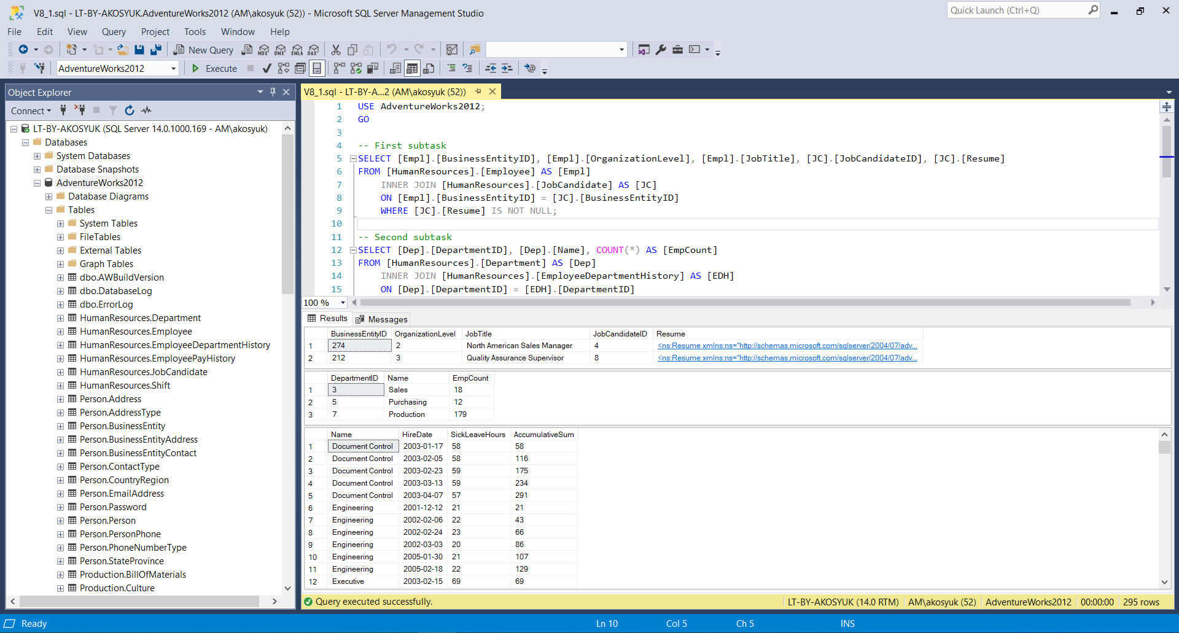

2. Second subtask: